LEC 19
Transaction in general do not take a lot of time to execute if there are no conflicts. If we consider that conflicts are rare, forcing transactions to acquire locks adds unnecessary overhead.
OPTIMISITIC CONCURRENCY PROTOCOLS
TIMESTAMP ORDERING CONCURRENCY CONTROL
Dbms utilizes timestamps to determine the serializability order of txns rather than using locks.
If Timestamp of txn1 is smaller than timestamp of txn 2, they must be executed as such that the concurrent execution of these transactions must be equivalent to the serial execution of txn1 followed by txn2
Timestamp allocation
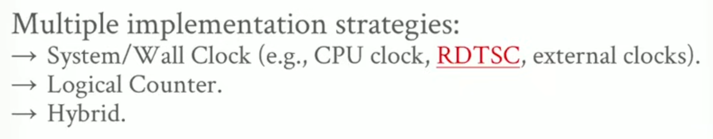
Postgres gives timestamps for the starting of a txn as well as the commit of a txn
OCC (Optimistic concurrency control)
Timestamp ordering protocol in which DBMS creates a private workspace for each txn.
Objects read and modification are stored in workspace.
When the txn commits, dbms checks the txn workspace write set to see if it if conflicts with other txns.
If no conflicts, the write set is installed into the global database.
It has 3 phases:
- READ: track the read/write sets of txn and store the writes in a private workspace.
- VALIDATION: When the txn calls commit, switch into this phase. Assign the txn a unique timestamp and check whether it conflicts with other txns.
- WRITE: when validated, apply the changes in the private workspace to the global database. Timestamp is not appended to the global database for the transaction and txn is aborted if validation fails.
An example
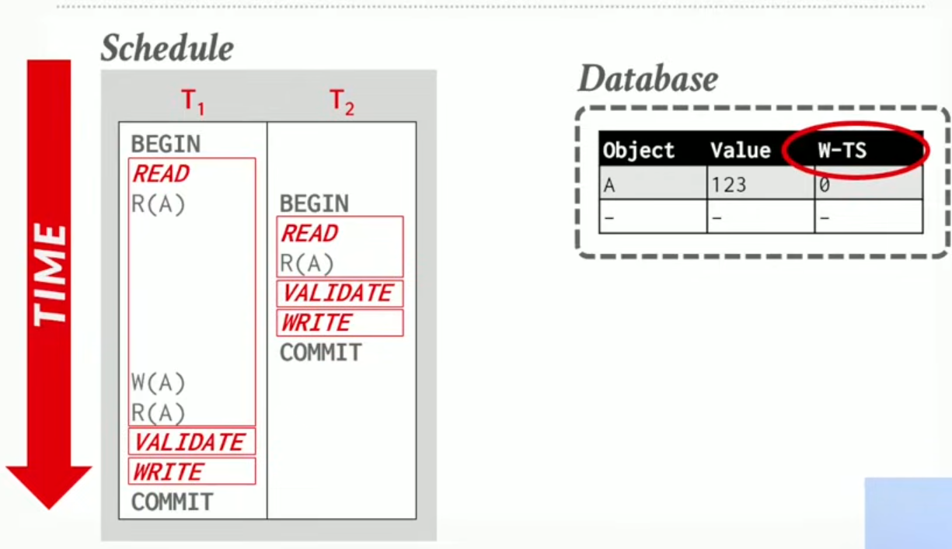
W-TS is the last committed transaction’s timestamp which wrote the value.
T1 reads A:
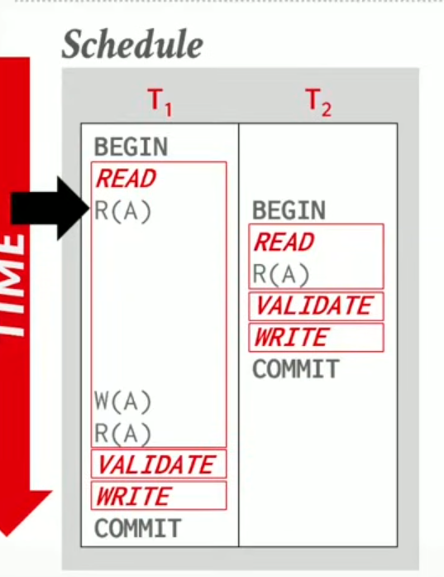
Copies the curr value of A into its private workspace
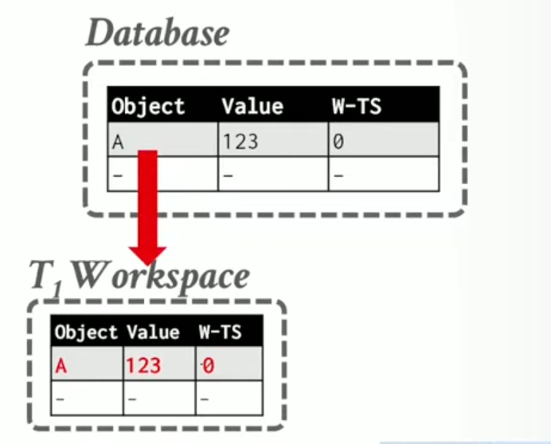
Now, t2 reads A:
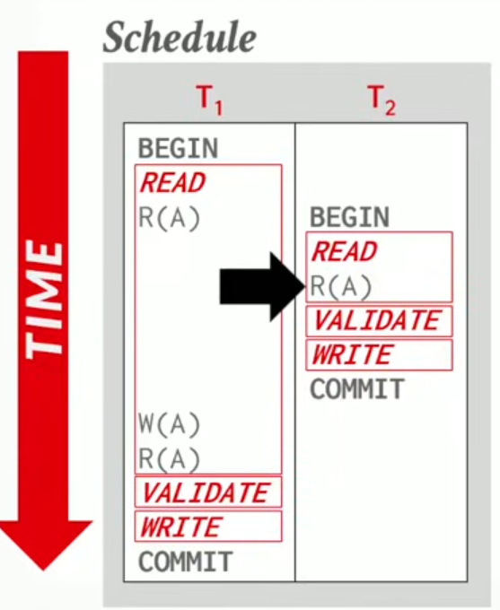
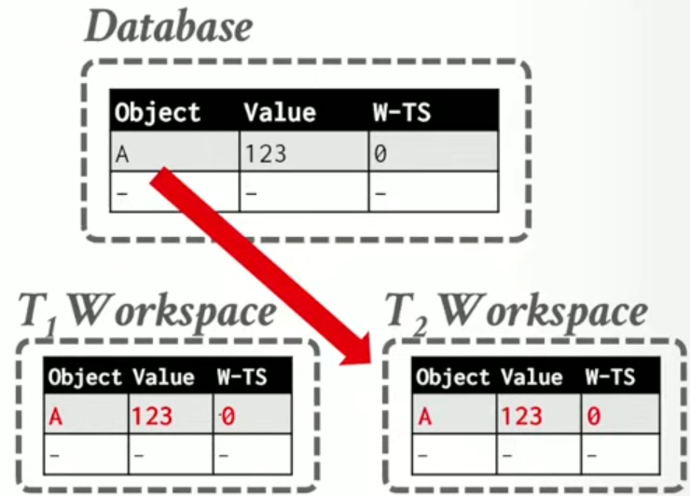
Now , t2 will validate,
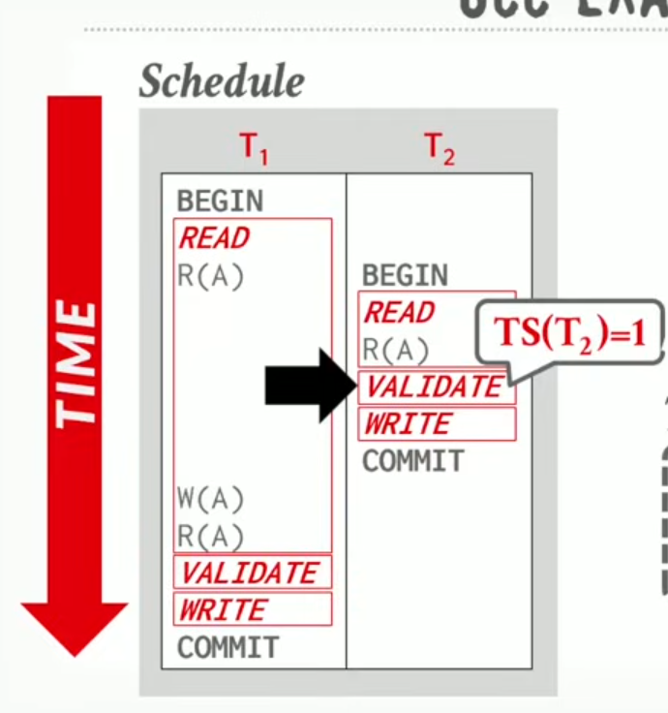
It gets timestamp 1 because it commits first.
We check the things t2 has read or wrote something that any of the other txns could have read or modified.
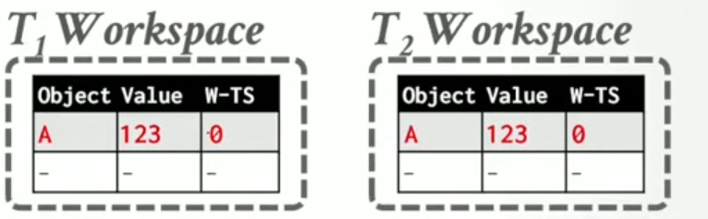since theres no conflict, we move onto write. But since theres no modifications to write for t2, we do nothing and just commit.
Now t1 writes on A
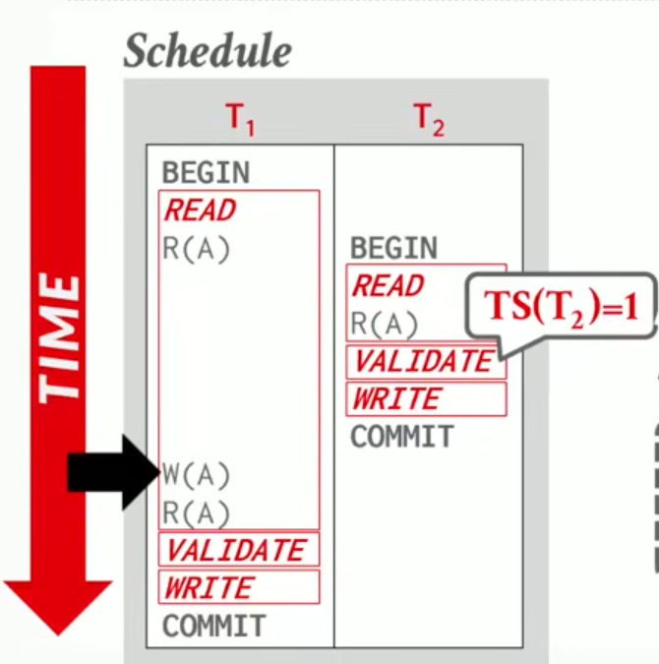
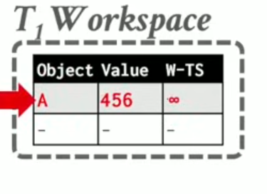
The timestamp is set to inf because we dont get a w-ts for our txns until the validate phase is reached.
T1 reads A now
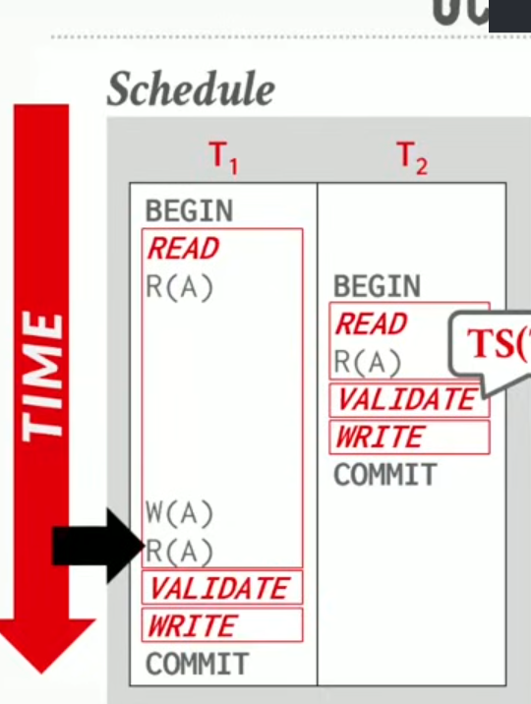
T1 moves onto validation phase now and assigned timestamp 2
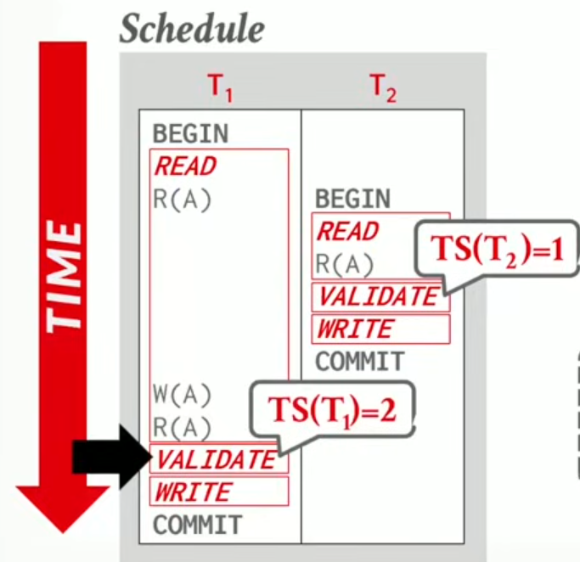
No conflicts because no other txns except for t1.
In the write phase, Applies the TS that was assigned in the validate phase to the private workspace and pushes the change upto the global database.
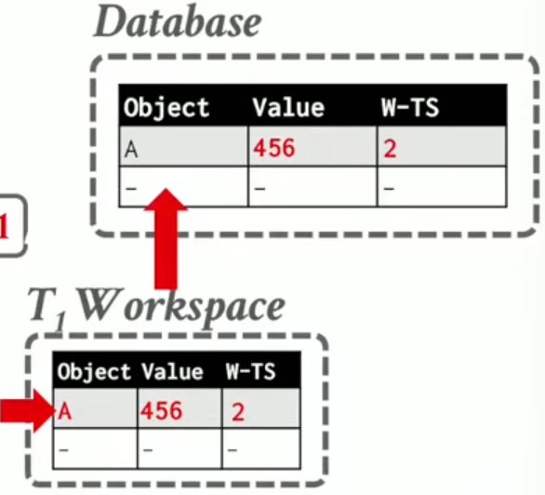
OCC VALIDATION APPROACHES:
- Forward Validation: Check to see if the current comitting transaction has a conflict with any of the active transactions that have yet to be committed.
- Backward Validation: Check to see if the current committing txn has a conflict with any of the already committed txns.
For forward validation there can be three cases:
- T1 has completed its write phase and t2 hasnt started its read phase, no conflicts as this just becomes a serial ordering where t2 starts after t1 commits.
- T1 completes its write phase before t2 starts its write phase and t1 doesnt modify any object read by t2, there are no conflicts.
- T1 reads A, then writes on A and the new value is updated in the t1 workspace write set.
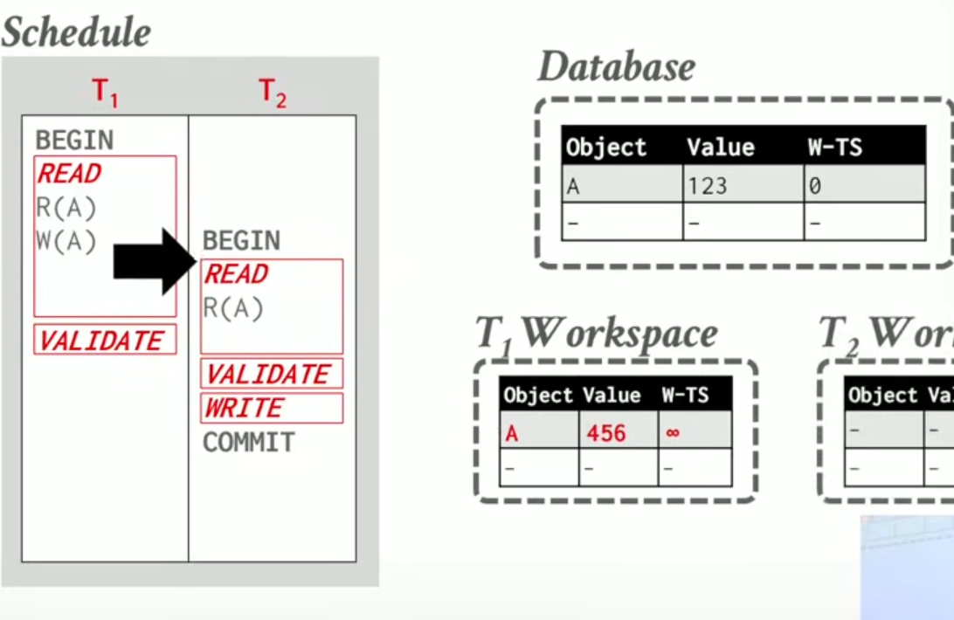
T2 now starts running and does a read on A.
Now t1 goes to validate state and wants to commit, we check the write set of the t1 with read set of t2, and there is a conflict
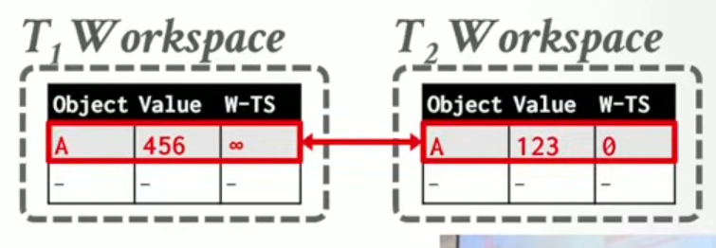
T1 will abort because t2 should see the updated value with the t1 timestamp that is acquired from the validate phase.
OCC : WRITE PHASE
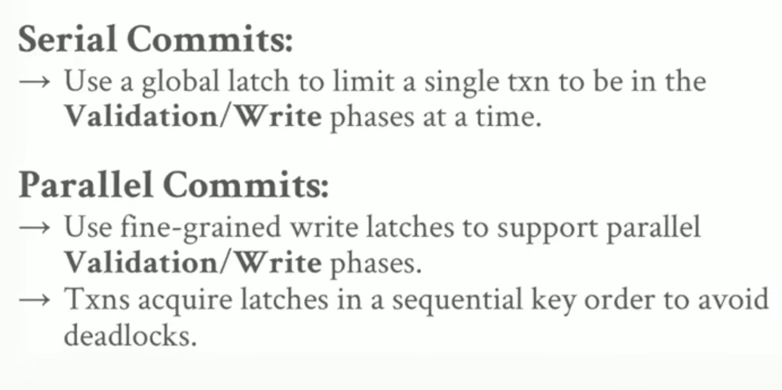
OCC GOODS AND BADS
Goods:
- Works very well when the no of conflicts is low.
- Ideal when all txns are read only
- Txns access disjoint subsets of data (t1 accesses a, t2 b, t3 c, so on).
Bads:
- Huge overhead for copying data locally (private workspaces)
- Aborts more wasteful than in 2 phase locking because aborts only applied after txn has been executed which is the opposite can in 2 phase locking.
The Phantom Problem
So far, we focused on txns that would update or read existing objects in the database.
What about when we have to delete and insert?
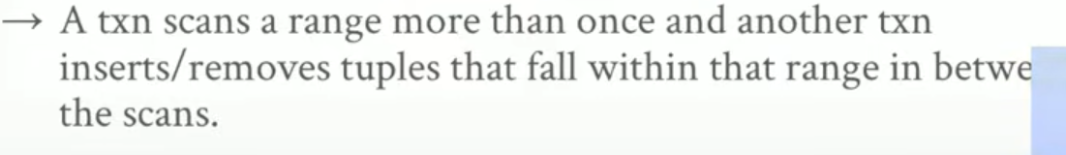
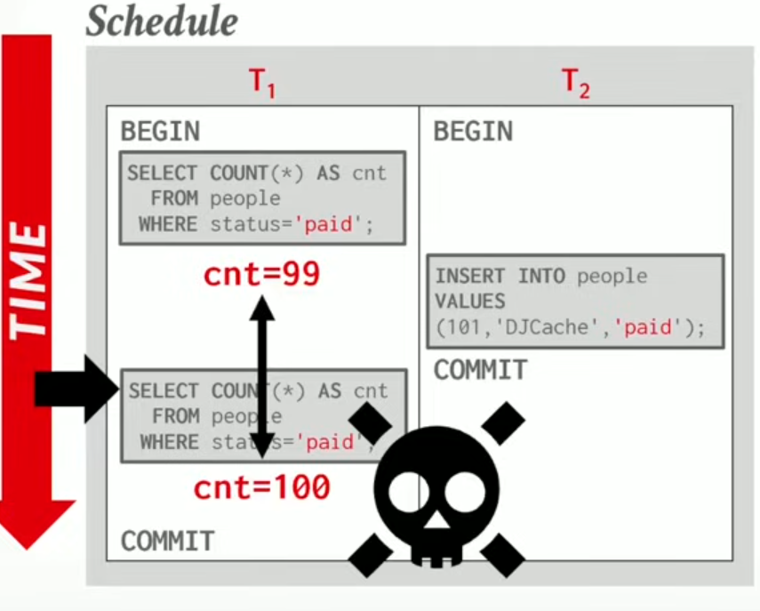
Select count of people for t1, which gives us 99. Now an insert transaction t2 commits,
The count now becomes 100. This gives us an unrepeatable read.
This is a problem for both 2 phase locking and OCC.
You can acquire locks on the existing records but not on ones that dont exist yet. This issue wouldn’t arise if it was executed according to serial ordering so its an issue.
This is a phantom read.
SOLUTIONS
- Lock everything : lock the entire table or the entire page
- Re-execute Scans: Run queries again at commit to see if any changes have been missed
- Predicate locking:
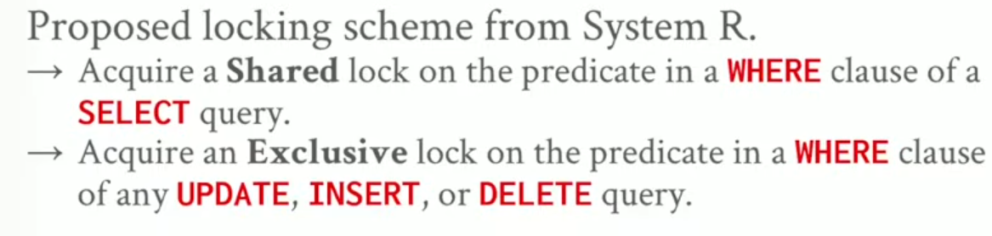
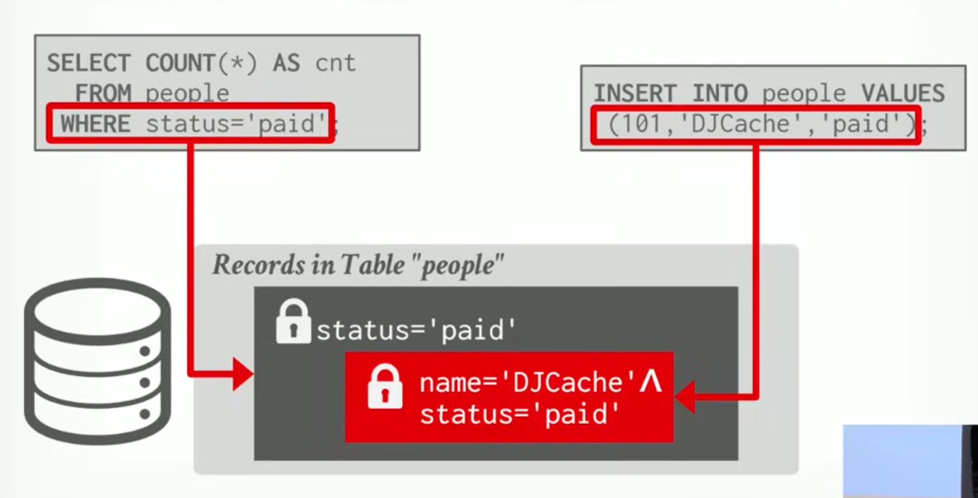
If the regions for both the queries overlap, theres a conflict in their predicate and you can decide through a protocol who is allowed to acquire the lock and whos allowed to commit.
- Index locking: Special case of predicate locking that acquires locks on key ranges in idexes.
If there is an index on the status attribute then the txn locks the index page containing the data with status=paid
If there are no records with status = paid the txn locks the index page where such data entry would be if it existed.
Index locking approaches:
- Key-Value locks
Lock the value using the k-v pair in the index data structure. The lock is stored in the lock manager not the index data struct itself.
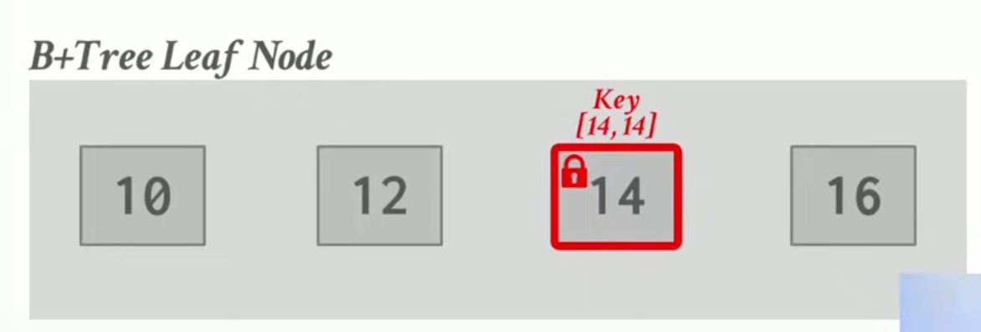
- Gap Locks
What if you want to take a lock on a value that doesn’t exit yet that you would potentially insert?
You take a lock on the gaps between the keys where the val would be inserted. This is called a Gap lock.
For example
When inserting 15,
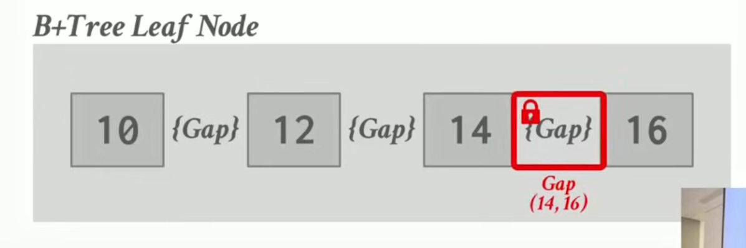
- Key-range locks
Don’t want to take locks on every single key value pair or every single gap that we may have within a range of values so we can combine them together to take key range locks.
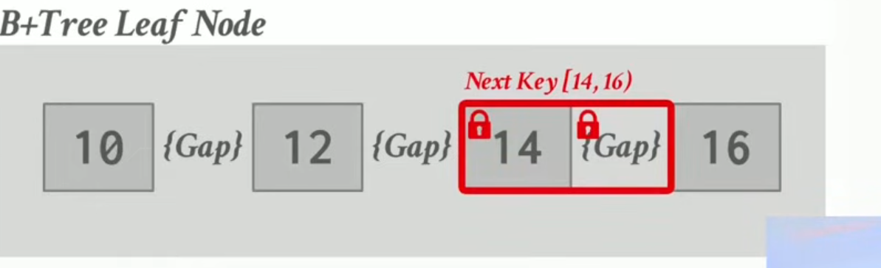
- Hierarchal locking
Same concept of IX, IS applies but here for actual values inside a page.
